03/06/2024
Borbjerg Sparekasse
Fr Esther Jensen Holdings
Feldorguej 4
7490 Aulum

Dear Mr S Dlamini
We trust you are fine. Firstly, we would like to appreciate the time we spent together in Eswatini, my delegation really enjoyed Mlilwane. Our discussions were very successful and we are happy to continue our relationship. We you remember very well that traditionally, we don’t support student doing PhD program nevertheless for you we decided to make a conditional exception.
- We can fully pay your tuition as long as you can agree to find a Job or Civilian attachment.
- Once you find any kind of Civilian Attachment that would enhance your integration program and experience, you shall send us the letter of attachment explaining clearly your duties, responsibilities or job description.
- We shall send a delegation on short notice to access and evaluate your duties thus their report shall be necessary to justify this sponsorship.
DESIRABLE:
The main focus is an attachment however it is desirable that you are responsible for your upkeep as we hope to only be responsible for your tuition fee only. Here in Denmark Normally universities assist by appointing student in your situation as tutors, interns or assistances wherever there is a need thus in return they receive a stipend to maintain themselves. Our advice is that explore such options. We hope to be updated on any progress.
Good luck with your Studies
Kind Regards
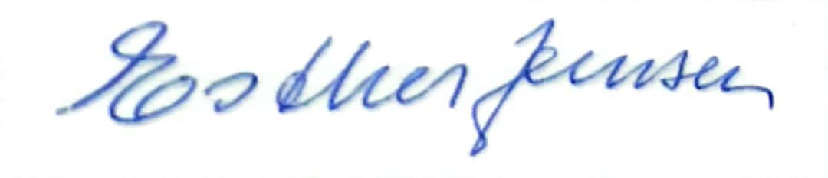
Esther Holding.

